STUDY ARRANGEMENT
- Schedule for Lectures (GMT+8)
Day 1
Time | Starting from 13:00 p.m., Jan. 25th, 2021
ZOOM | Meeting ID: 774 093 0224  Passcode: XJTU
Title | “Embrace the world beyond space limitation”- opening ceremony
Day 2
Time | Starting from 13:00 p.m., Jan. 26th, 2021
ZOOM | Meeting ID: 774 093 0224  Passcode: XJTU
Title | "Experiencing Xi'an, a thousand years of dream"-- History and culture of ancient capital
Reporter | Associate Professor Huang Pingan
Day 3
Time | Starting from 13:00 p.m., Jan. 27th, 2021
ZOOM | Meeting ID: 774 093 0224  Passcode: XJTU
Title | Photocatalytic Solar Hydrogen Production from Water
Reporter | Prof. Liu Maochang
Day 4
Time | Starting from 13:00 p.m., Jan. 28th, 2021
ZOOM | Meeting ID: 774 093 0224  Passcode: XJTU
Title | “Combination of body and spirit” -- Tai Chi philosophy
Reporter | Wang Weifeng
Day 5
Time | Starting from 15:00 p.m., Jan. 29th, 2021
ZOOM | Meeting ID：729 308 2791  Passcode：XJTU
Title | People Don't Know What They Want until You Show it to Them, But When?
Reporter | Associate Professor Xiangyu Chang
Day 6
Time | Starting from 13:00 p.m., Jan. 30th, 2021
ZOOM | Meeting ID: 774 093 0224  Passcode: XJTU
Title | 5G Communications: Overview and Practical Applications
Reporter | Prof. Chen Xiaoming
Day 7
Time | Starting from 13:00 p.m., Jan. 31st, 2021
ZOOM | Meeting ID: 774 093 0224  Passcode: XJTU
Title | "A Gathering of Stars"- closing ceremony
- Schedule for learning Chinese Language and Culture
We will update 2 videos on Chinese language and culture every day before 9:00 a.m. (Beijing Time). You can watch them freely on the website at: http://sie.xjtu.edu.cn/en/VIDEO_WALL.htm
- How to get your Certificate of Recognition?
- Write down what you have learned or been inspired from the lecture or the videos.
- Scan the QR code or click the link to fill what you have written down in the form “Daily Progress for 2021 XJTU Winter Camp of the Silk Road” from 14:00 Jan 30,2021 to 8:00 am Jan 31, 2021.
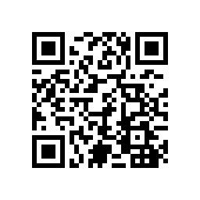
https://www.wjx.cn/vj/PYHWvFs.aspx
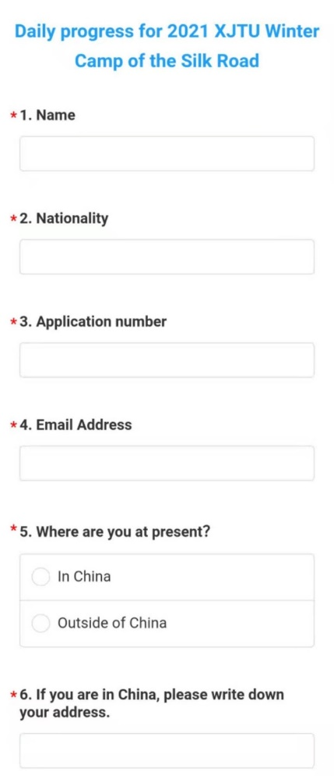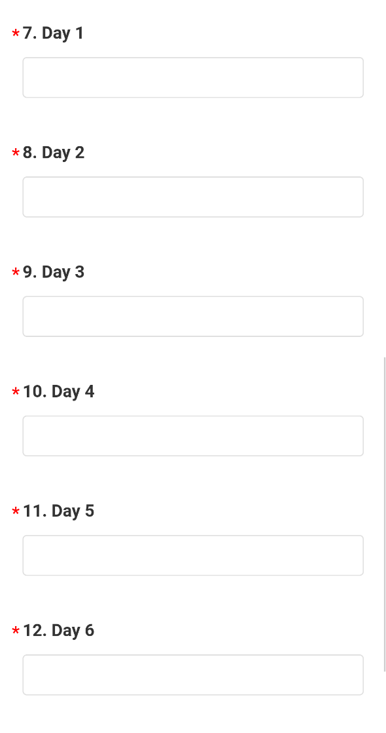
- We will review what you have submitted and inform you the name list who comlpeted the Winter Camp at the closing ceremony.
- We will email the Certificate of with a week after the closing ceremony.
* Master and Ph.D Students of XJTU can get 2 stamps on your ECL/S form after the winter camp. You shall take screenshots at the beginning and the end of each lecture respectively. At the end of the winter camp, you need to compress all the screenshots into a zip file, name the file as "your name+major+student number", and send it to turboz@xjtu.edu.cn.
- How to get a customized sweater and a “Certificate of Outstanding Performance” ?
There are 30 seats. If you meet one of the following requirements, you will get the mentioned sweater and certificate. Due to the Covid-19 pandemic, those who aren’t in China now will only get the “Certificate of Outstanding Performance”.
- “Daily Progress for 2021 XJTU Winter Camp of the Silk Road” is evaluated as “Excellent”.
- Did wonderful volunteer work during the Winter Camp.
- Share a post about XJTU on Instagram or other commonly used social media platforms and get 100 hearts/Thumbs-up/likes. The post is as follows:

Words(Similar) | Winter Camp of Xi’an Jiaotong University, China. The ancient capital, beautiful campus, wonderful professors, and also the most cutting-edge science and technology…
Pics | 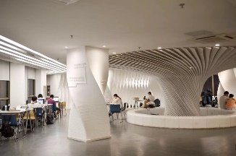  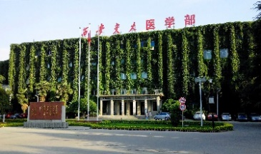  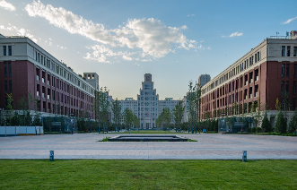  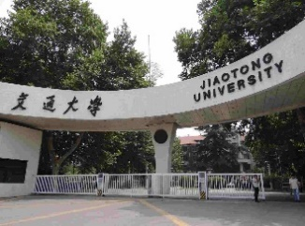  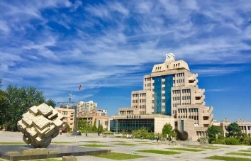  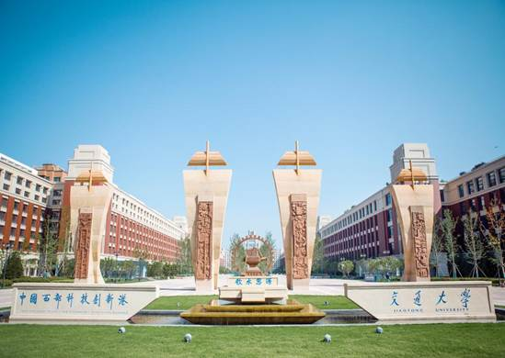
- What can the "Certificate of Outstanding Performance" be used for?
Those who perform well can get a "Certificate of Outstanding Performance" (electronic version). Applying for degree programs of XJTU within 2 years, they will be given priority for admission and be exempted from the application fee.

